**PROJECT 1 – EXPLORE WEATHER TRENDS**

1. **Fetching data using SQL queries and making csv**

SELECT city_data.city AS "City Name",

city_data.year AS "Year",

city_data.avg_temp AS "City Average Temp.",

global_data.avg_temp AS "Global Average Temp."

FROM city_data JOIN global_data ON

city_data.year = global_data.year

WHERE city_data.city='Delhi'

1. **Calculating the moving average and plotting the line charts**
2. The above data was fetched using SQL and data was saved into the csv file and moving averages were calculated as shown below.

I have taken 7 year moving average into consideration.

I have calculated and compared data for which both global and data exists.

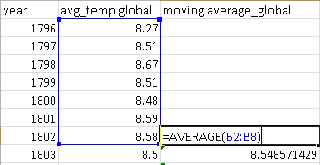

1. Then the line charts were created by selecting the data for which need to create it and then suitable titles and legends were added so that the viewer gets all the necessary information by just having a glance.

Below is line chart that was created for moving average for Global and city level data.

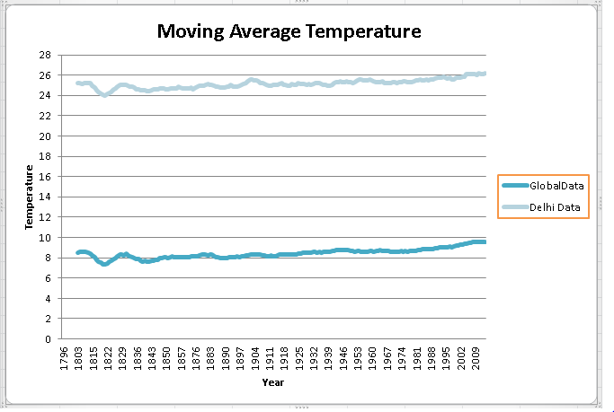

1. **Making observations from the above line graph**
2. The average global temperature falls within the range of 6 to 10 degree Celsius whereas the average temperature for Delhi falls within the range of 23 to 27 degree Celsius.
3. The difference between global and city level temperature is approximately 17 degree Celsius.
4. Delhi has comparatively higher average temperature as compare to global average temperature.
5. The average temperature both globally and locally doesn’t follow any particular increasing or decreasing trend.